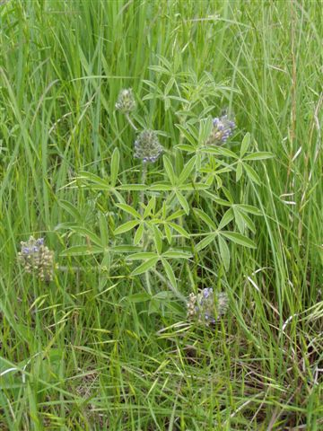  From the land of Dwight Eisenhower  - of buffalo and tall grass prairie  - of sunflowers & Home on the Range...comes great adventures in:  Fresh  Feathered  Eggs  By  Dr. John F. Burgess  and  Col. George D. Burgess |  | Fresh  Feathered      Eggs  “A story of America past—of love and humor—of values and stick-to-it-ness.”  “It’s the joy of living in a time of trust and rewarding hard work—a faith walk-country tale that makes you ask for more.”  Publication Date: 12/1/05  Photo by Dr. Barbara Burgess at  Flintrock Road, Wamego, KS  (Prairie potato amid bluestem)  © 2005 |  | Fresh Feathered Eggs is fresh! And, it’s all true…or could be. Brothers, Freddy and George, live through fresh feathered eggs, ‘accidental’ car rides, bathroom episodes, one-pig diners, Aunt Maggie’s blue jays, milking school, being a hop too slow, the wrong color calf, a lily-livered puff, painting like P. Kosso, the seating of pew number three, cow-tail skiing, church-camp undercover undressing, and more. And, they meet the challenges by falling back on family values developed from their Christian walk.  And what about neighbors? This is also the real-life story of real-life friends and family. Sometimes, however, to protect the not-so-innocent, part of the story is disclosed by the fictitious Brockman family…those people that don’t quite get it right (every neighborhood has them) and who end up on the short end of many practical jokes and self-inflicted humorous events.  How to order:  At a bookstore near you; or at  Infinity Publishing  1094 New Dehaven St. Suite 100  West Conshohocken, PA 19428  Phone: 610-941-9999  Fax: 610-941-9959  Or via the Internet:  www.buybooksontheweb.com  www.burgessbrothersbooks.com

